LAB No. 7
Naïve Bayes Classification
Lab No. | 7
Lab Aim | To implement the Naïve Bayes Classification algorithm using a suitable dataset.
Objectives | 1. To understand Bayes' theorem and the conditional independence assumption.  2. To implement Gaussian and Multinomial Naïve Bayes classifiers in Python.  3. To evaluate the model using accuracy, precision, recall, F1-score and the confusion matrix.
Dataset / Resources Used | Iris dataset (150 samples, 4 features, 3 classes) from scikit-learn; a small custom 16-message spam/ham text set; Python 3, scikit-learn, pandas, NumPy, Matplotlib.
Date of Performance | 24 October 2026
Name / Roll No. | Vedant Garhewal / 47
Section / Batch | C / C4

1. Theory
Naïve Bayes is a family of supervised probabilistic classifiers based on Bayes' theorem. Given a feature vector X = (x1, x2, …, xn), it computes the posterior probability of every class C and predicts the class with the highest value:
P(C | X) = [ P(X | C) × P(C) ] / P(X)
The "naïve" assumption is that the features are conditionally independent given the class, so the likelihood factorises as P(X | C) = P(x1|C) × P(x2|C) × … × P(xn|C). The predicted class is therefore ŷ = argmax over C of [ P(C) × Π P(xi | C) ]. Since P(X) is the same for all classes, it can be ignored during prediction.
Variants of Naïve Bayes differ in how they model P(xi | C):
- Gaussian NB assumes continuous features follow a normal distribution, with a per-class mean and variance estimated from training data.
- Multinomial NB models discrete counts such as word frequencies; it is widely used for text and spam classification. Laplace smoothing (alpha) avoids zero probabilities.
- Bernoulli NB models binary (present/absent) features.
Naïve Bayes needs very little training data, trains in a single pass, and scales well to high-dimensional data. Its performance is evaluated using accuracy, precision, recall, F1-score and the confusion matrix.

2. Source Code (GitHub)
The complete source code has been uploaded to GitHub at the following URL:
https://github.com/<your-username>/<repo-name>/blob/main/naive_bayes_lab7.py
File: naive_bayes_lab7.py. The code is also reproduced below for reference.
"""
Lab 7: Naive Bayes Classification
Dataset: Iris (scikit-learn built-in) - Gaussian Naive Bayes
Also: SMS-style spam text sample - Multinomial Naive Bayes
"""

import numpy as np
import pandas as pd
import matplotlib.pyplot as plt
from sklearn.datasets import load_iris
from sklearn.model_selection import train_test_split
from sklearn.naive_bayes import GaussianNB, MultinomialNB
from sklearn.feature_extraction.text import CountVectorizer
from sklearn.metrics import (accuracy_score, classification_report,
confusion_matrix, ConfusionMatrixDisplay)

# ---------------------------------------------------------------
# Part A: Gaussian Naive Bayes on the Iris dataset
# ---------------------------------------------------------------
iris = load_iris(as_frame=True)
X, y = iris.data, iris.target
print("Dataset shape:", X.shape)
print("Classes:", [str(c) for c in iris.target_names])
print(X.head())

X_train, X_test, y_train, y_test = train_test_split(
X, y, test_size=0.3, random_state=42, stratify=y)
print("\nTrain size:", len(X_train), " Test size:", len(X_test))

model = GaussianNB()
model.fit(X_train, y_train)
y_pred = model.predict(X_test)

print("\nClass priors:", np.round(model.class_prior_, 3))
print("Accuracy:", round(accuracy_score(y_test, y_pred), 4))
print("\nClassification Report:")
print(classification_report(y_test, y_pred, target_names=iris.target_names))

cm = confusion_matrix(y_test, y_pred)
print("Confusion Matrix:\n", cm)

ConfusionMatrixDisplay(cm, display_labels=iris.target_names).plot(cmap="Blues")
plt.title("Gaussian NB - Iris Confusion Matrix")
plt.tight_layout()
plt.savefig("confusion_matrix.png", dpi=150, facecolor="white")
plt.close()

sample = pd.DataFrame([[5.1, 3.5, 1.4, 0.2]], columns=X.columns)
print("\nPrediction for", sample.values[0].tolist(), "->",
iris.target_names[model.predict(sample)[0]])
print("Probabilities:", np.round(model.predict_proba(sample)[0], 4))

# ---------------------------------------------------------------
# Part B: Multinomial Naive Bayes for text (spam / ham)
# ---------------------------------------------------------------
texts = [
"win a free prize now", "free entry claim your reward", "urgent cash offer click now",
"congratulations you won a lottery", "get cheap loans instantly", "free gift voucher limited offer",
"meeting at 10 am tomorrow", "please submit the lab report", "lunch at the canteen today",
"assignment deadline is friday", "call me when you reach home", "project discussion with the team",
"claim free cash prize today", "see you in class tomorrow", "viva scheduled for monday morning",
"exclusive offer win money now",
]
labels = [1, 1, 1, 1, 1, 1, 0, 0, 0, 0, 0, 0, 1, 0, 0, 1] # 1 = spam, 0 = ham

vec = CountVectorizer()
Xt = vec.fit_transform(texts)
Xt_tr, Xt_te, yt_tr, yt_te = train_test_split(
Xt, labels, test_size=0.25, random_state=1, stratify=labels)

mnb = MultinomialNB(alpha=1.0)
mnb.fit(Xt_tr, yt_tr)
print("\n--- Text classification (Multinomial NB) ---")
print("Test accuracy:", accuracy_score(yt_te, mnb.predict(Xt_te)))

for msg in ["free cash prize offer", "submit the report before the viva"]:
p = mnb.predict(vec.transform([msg]))[0]
pr = mnb.predict_proba(vec.transform([msg]))[0]
print(f"'{msg}' -> {'SPAM' if p else 'HAM'} (P(ham)={pr[0]:.3f}, P(spam)={pr[1]:.3f})")

3. Procedures and Materials Used
Materials: a computer with Python 3, the libraries scikit-learn, pandas, NumPy and Matplotlib, and the built-in Iris dataset.
Procedure:
- Import the required libraries and load the Iris dataset using load_iris().
- Inspect the data (shape, class names, first five rows).
- Split the data into 70% training and 30% testing sets using train_test_split() with stratification and random_state = 42.
- Create a GaussianNB model and train it with fit() on the training set.
- Predict the labels of the test set with predict() and compute accuracy, the classification report and the confusion matrix.
- Plot the confusion matrix as a heat-map and predict the class of a new sample.
- For text data, convert messages into word-count vectors using CountVectorizer, train a MultinomialNB model (alpha = 1) and classify new messages as spam or ham.

4. Output Screenshots and Descriptions
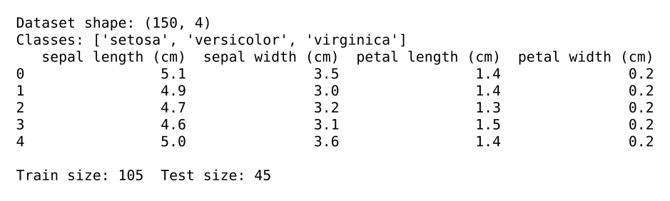
Output 1: Dataset loading and train-test split
The Iris dataset is loaded from scikit-learn and has 150 samples with 4 numeric features: sepal length, sepal width, petal length and petal width. The three target classes are setosa, versicolor and virginica. The first five rows are printed to verify the data. The data is split 70:30 with stratification, giving 105 training and 45 testing samples with equal class balance.
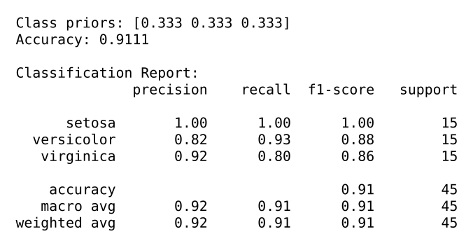
Output 2: Accuracy and classification report
The Gaussian Naive Bayes model learned equal class priors of 0.333 for each class. It achieved an overall accuracy of 91.11% on the 45 test samples. Setosa is classified perfectly, with precision and recall of 1.00. Versicolor and virginica have slightly lower F1-scores of 0.88 and 0.86, since their feature ranges overlap. The macro and weighted averages are both about 0.91.
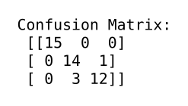
Output 3: Confusion matrix (numeric)
The confusion matrix shows 15 of 15 setosa, 14 of 15 versicolor and 12 of 15 virginica samples correctly classified. One versicolor sample was predicted as virginica, and three virginica samples were predicted as versicolor. No setosa sample was ever misclassified. All 4 errors occur between the two overlapping classes, which agrees with the classification report.
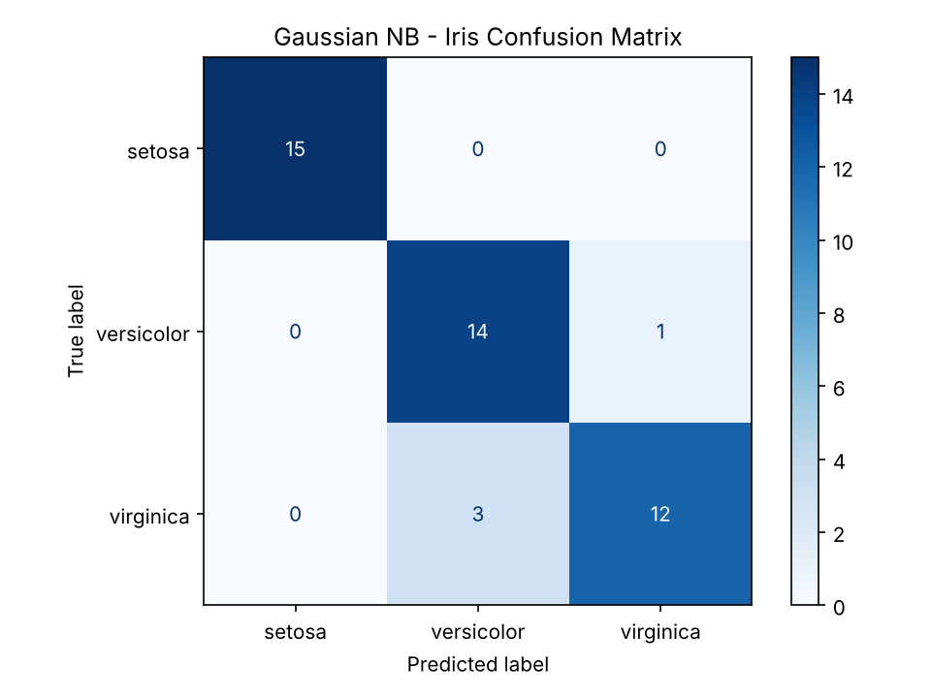
Output 4: Confusion matrix heat-map
This heat-map plots the same confusion matrix, with the true class on the vertical axis and the predicted class on the horizontal axis. A strong diagonal with darker cells shows that most predictions are correct. The only off-diagonal cells are the versicolor/virginica pair. The plot makes it easy to see which classes the model confuses, rather than just the overall accuracy.
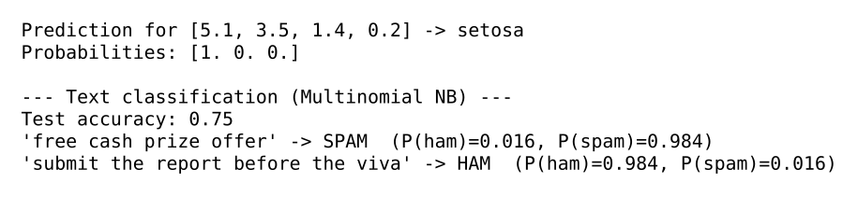
Output 5: Single-sample prediction and text (spam) classification
For the sample [5.1, 3.5, 1.4, 0.2], the model predicts setosa with probability 1.0. The Multinomial Naive Bayes spam filter, trained on a small 16-message set, reaches 75% test accuracy. The message "free cash prize offer" is classified as SPAM with probability 0.984. The message "submit the report before the viva" is classified as HAM with probability 0.984.

5. Viva Questions with Solutions
Q1. What is the Naive Bayes classifier and why is it called "naive"?
Ans: Naive Bayes is a probabilistic classifier based on Bayes' theorem, P(C|X) = P(X|C)·P(C) / P(X). It is called naive because it assumes that all features are conditionally independent given the class. This is rarely true in real data, but the simplification makes the model fast and often surprisingly accurate.
Q2. Write Bayes' theorem and explain prior, likelihood and posterior.
Ans: Posterior P(C|X) is the probability of the class after seeing the features. Prior P(C) is the probability of the class before seeing any data. Likelihood P(X|C) is the probability of the observed features given the class. The evidence P(X) is a normalising constant, so the predicted class is the one that maximises likelihood × prior.
Q3. What are the different types of Naive Bayes classifiers and when is each used?
Ans: Gaussian NB is used for continuous features assumed to follow a normal distribution (e.g. Iris). Multinomial NB is used for count data such as word frequencies in text classification. Bernoulli NB is used for binary features (word present or absent). The choice depends on the type and distribution of the features.
Q4. What is Laplace (additive) smoothing and why is it needed?
Ans: If a feature value never appears with a class in the training data, its likelihood is zero and the whole product becomes zero. Laplace smoothing adds a small constant alpha (usually 1) to every count so that no probability is exactly zero. In scikit-learn this is the alpha parameter of MultinomialNB.
Q5. List advantages and limitations of Naive Bayes.
Ans: Advantages: it is simple, very fast to train and predict, works well with small datasets and high-dimensional data such as text, and handles multi-class problems naturally. Limitations: the independence assumption is unrealistic, so correlated features can reduce accuracy; probability estimates may be poorly calibrated; and unseen feature values need smoothing.

6. Conclusion
The Naïve Bayes classifier was implemented successfully. The Gaussian model achieved 91.11% accuracy on the Iris test set, and the Multinomial model correctly classified new text messages as spam or ham. Despite its simple independence assumption, Naïve Bayes proved to be a fast and effective classification algorithm.

